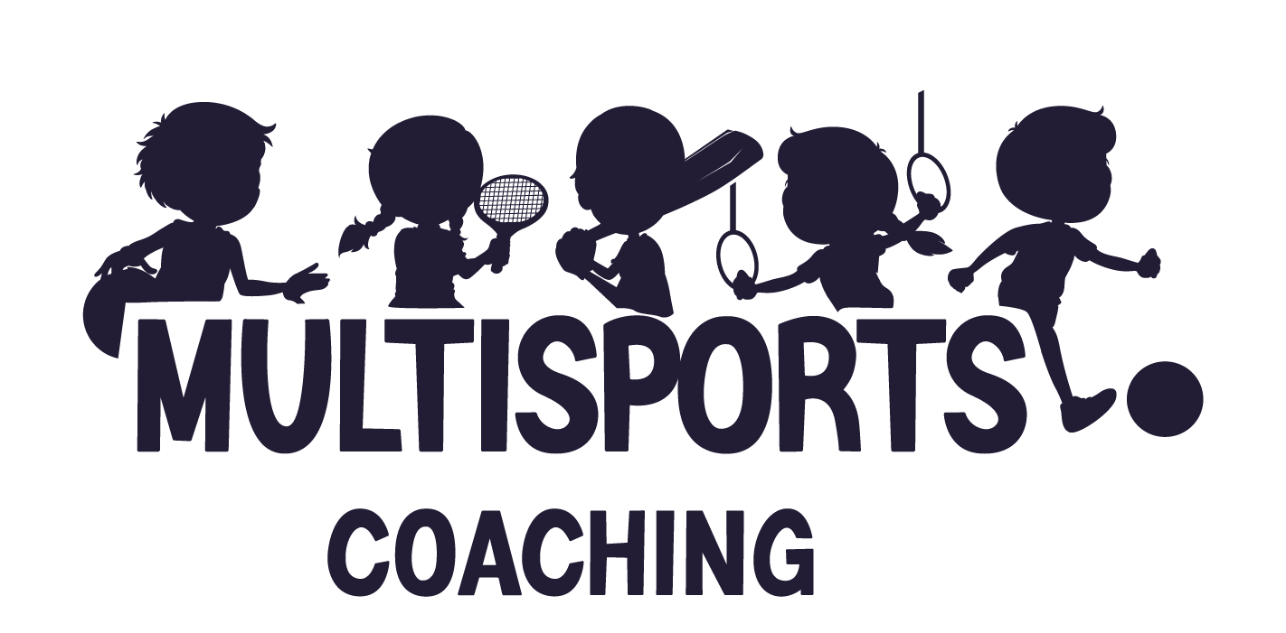

Safeguarding Policy

Please take a moment to carefully read through our safeguarding policy which has been created to ensure children are protected to ensure they have a safe place in which to play and be active.

Certifications
Our coaches are DBS checked, have first aid & safeguarding certifications.
These are renewed every 3 years and our coaches are responsible for completing updates, keeping up to date with relevant publications and being aware of any changes to policies & legislations.

Culture & Behaviour management
MiniSports work hard to create a culture where children feel safe, comfortable, and able to be themselves.
Our coaches always listen to children; we treat others how we would like to be treated & we always demonstrate good behaviour examples.
Some of the rules in place are:
- When one person is speaking, others must listen
- Be kind to everybody; kind hands & kind mouths
- Treat others how you would want to be treated
- Always help people if they are hurt/upset

Arrival & Dismissal
All children must be signed in by a coach through a physical parent to coach handover. Children must not be left at the school gates and must not arrive to camp on their own. All children are acknowledged by a coach, parents must not leave children until this has been done.
At the end of the day, children will be handed back to parents. Please also note that only adults with prior approval will be able to collect – parents must either add these on the booking system (KidsClubHQ) or notify the coach at drop-off.
For after-school clubs, we use the wave off policy; children will not be dismissed until we receive a wave back from the parent/carer/designated adult.

Expectations whilst in our care
Whilst in our care, children will be looked after, kept safe & we must always know their whereabouts. Children are required to ask if they need to use the toilets, require a drink, or have another reason to leave an activity.
If children require prescription medication, please inform the coach at drop-off; medication can be given as long as it is prescribed from the doctors, with all of the required information clearly labelled (name, date & dosage instructions).

Our responsibility as role models
As role models we must…
- Display the correct behaviour
- Speak in the correct way
- Make sure all children are happy, safe & thriving
- Create an environment where children want to be

Recognising and responding to bullying
If we receive any reports of bullying from a child or a parent, we deal with it seriously and immediately.
Bullying encompasses a range of behaviours which may be combined and may include the behaviours and actions we have set out below.
Verbal abuse:
- name-calling
- saying nasty things to or about a child or their family
Physical abuse:
- hitting a child
- pushing a child
- physical assault
All of our strategies work to PREVENT bullying before it occurs, RECOGNISE potential bullying in the early stages & RESPOND to bullying with a zero-tolerance approach.

Reporting or Responding to concerns
Children have the right to be protected from harm.
As an organisation we are committed to protecting all children whilst they are in our care, and we also have a duty to look after them if we have reason to believe they are not being cared for outside of our sessions also.
We ensure we recruit the correct staff and ensure they have the relevant qualifications to be well informed to deal with any safeguarding matters.
MiniSports have a clear set of guidelines about how we will:
- Keep children safe
    - We have various policies in place to ensure this happens whilst children are in our care such as safeguarding certifications.
- Respond to child protection concerns
  - We will take the appropriate action necessary whether this is involvement from parents/guardians, schools or institutions or local authorities.
- We are governed by Sport England and abide by their safeguarding legislations & policies.

Photography & Imagery
All our parents must read our media policy to ensure they are aware of how photography will be used.

If you have any safeguarding concerns, please contact us on info@multisportscoaching.co.uk

