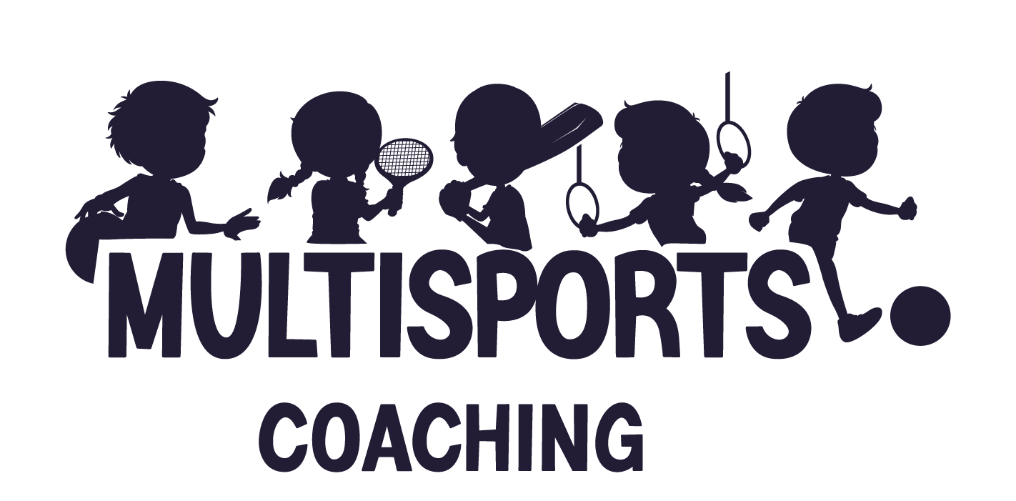

Safeguarding Policy

Please take a moment to carefully read through our safeguarding policy which has been created to ensure children are protected to ensure they have a safe place in which to play and be active.

Certifications
Our coaches are enhanced DBS checked and no coach will work for us unless they have a clean DBS without cautions, convictions, reprimands or warnings. We also provide paediatric first aid & safeguarding children certifications and training.
These are renewed every 3 years, and our coaches are responsible for completing updates, keeping up to date with relevant publications and being aware of any changes to policies & legislations.

Culture & Behaviour management
We work hard to create a culture where children feel safe, comfortable, and able to be themselves.
Our coaches always listen to children; we treat others how we would like to be treated & we always demonstrate good behaviour examples.
Some of the rules in place are:
- When one person is speaking, others must listen
- Be kind to everybody; kind hands & kind mouths
- Treat others how you would want to be treated
- Always help people if they are hurt/upset
- Coaches are always there to help so never be afraid to talk to them

Arrival & Dismissal
All children must be signed in by a coach through a physical teacher/parent to coach handover.
Children must not be left at the school gates or anywhere within our sites without being acknowledged by a coach.
children must not arrive to camp or any activity on their own.
Any children on our register but not in attendance will be followed up to ensure we are aware of their whereabouts – this will be via a conversation with the teacher, parent or the person responsible for bringing them to our care.
Any children who attend our club but are not on the register will be followed up immediately to ensure their whereabouts are known and consent for their care is given.
All children are acknowledged by a coach, parents must not leave children until this has been done.

At the end of a session, children will be handed back to parents. Please also note that only adults with prior approval will be able to collect – parents must either add these on the booking system (Class4kids) or notify the coach/teacher at drop-off.
For after-school clubs, we use the wave off policy; children will not be dismissed until we receive a wave back from the parent/carer/designated adult. Parents are required to come and collect their children from the coach and only then will children be handed over. Coaches will sign children out of the club once they are collected by an assigned adult.
Registers are completed on our live, up to date class4kids online register. Where necessary, paper registers or school booking systems e.g. socs will also be used to ensure they are kept up to date.
Any paper registers are the property of the school and will not be removed from the school site to comply with gdpr.
Children attending an additional club e.g. wraparound provided by the school, late collection clubs or another sport/activity – parents must inform us if their child is being handed to another third party club at the beginning of term.
at the beginning of each term our coaches will liaise with any other providers to align registers and ensure both parties know where children are supposed to be at before and after they are in our care.

Aspects of our safeguarding policies continue to be reliant upon individual school/venues procedures and protocols and due to the nature of our business, these will vary across sites but we endeavour to adhere to our own club policies.

Expectations whilst in our care
Whilst in our care, children will be looked after, kept safe & we must always know their whereabouts. Children are required to ask if they need to use the toilets, require a drink, or have another reason to leave an activity.
If children require prescription medication, please inform the coach at drop-off; medication can be given if it is prescribed from the doctors, with all of the required information clearly labelled (name, date & dosage instructions).

Information sharing
We must be made aware of any relevant medical or behavioural needs which are individual to a child. If a child had an EHC plan we must be made aware of this so we can ensure their needs are acknowledged and we as a provision can work out if we can put in place the relevant additional support.
Where possible, the school senco will provide a detailed and relevant account of an individual childs needs to the coach responsible for the child so the additional support needs are met.

Our responsibility as role models
As role models we must…
- Display the correct behaviour
- Speak in the correct way
- Make sure all children are happy, safe & thriving
- Create an environment where children want to be and are safe

Recognising and responding to bullying
If we receive any reports of bullying from a child or a parent, we deal with it seriously and immediately.
Bullying encompasses a range of behaviours which may be combined and may include the behaviours and actions we have set out below.
All behaviour we deem to be bullying will be dealt with directly with parents and where necessary, there will be school involvement too. Our policy on dealing with bullying is to ensure open, factual communication with all parties.
Verbal abuse:
- name-calling
- saying nasty things to or about a child or their family
Physical abuse:
- hitting a child
- pushing a child
- physical assault
All our strategies work to PREVENT bullying before it occurs, RECOGNISE potential bullying in the early stages & RESPOND to bullying with a zero-tolerance approach.

Reporting or Responding to concerns
Children have the right to be protected from harm.
As an organisation we are committed to protecting all children whilst they are in our care, and we also have a duty to look after them if we have reason to believe they are not being cared for outside of our sessions also.
We ensure we recruit the correct staff and ensure they have the relevant qualifications & training to be well informed to deal with any safeguarding matters.
Staff receive weekly team meetings & termly team training on all safeguarding matters as well as individual school safeguarding policies and individual annual training.
WE have a clear set of guidelines about how we will:
- Keep children safe
    - We have policies and training in place to ensure this happens whilst children are in our care.
- Respond to child protection concerns
  - We will take the appropriate action necessary whether this is involvement from parents/guardians, schools or institutions or local authorities.

Photography & Imagery
All our parents must read our media policy to ensure they are aware of how photography will be used.

If you are unsure, please refer to the keeping children safe in education 2023 document available on gov.uk.

If you have any safeguarding concerns, please contact us on info@multisportscoaching.co.uk

